excuse me WHAT 😢

AH! JEHOVAH IS WITNESS!

THERE IS GOD OOOO!

Pain and suffering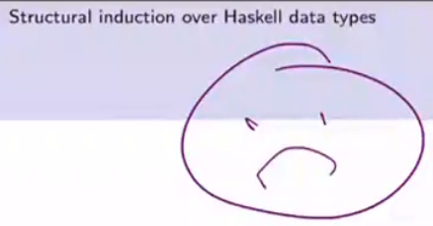

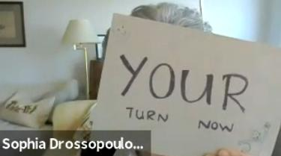





I LOVE LEAN!!!!! 💜💜💜

Mark wheelhouse more like mark generously pls <3

Mark scheme? Nah Mark scheming D:

jk java wasn’t too shabby compared to haskell 💀

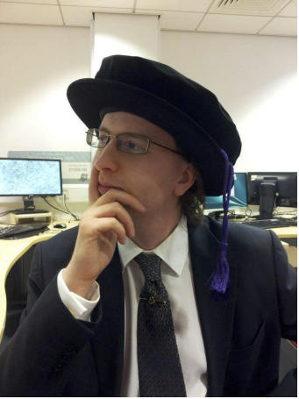Me contemplating my salary if I drop out and become a binman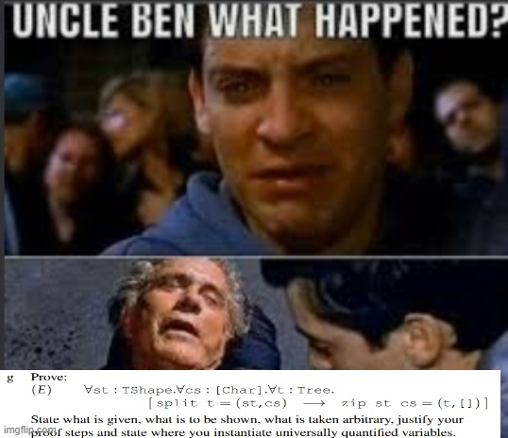

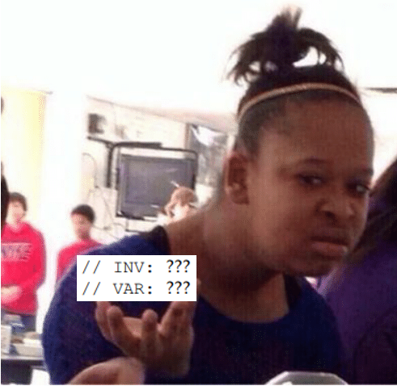



Me saying goodbye to my hopes of passing 40018

They really took both Ls from Haskell and gave them to me

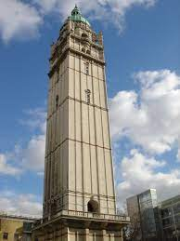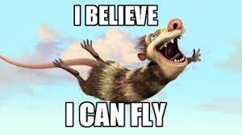

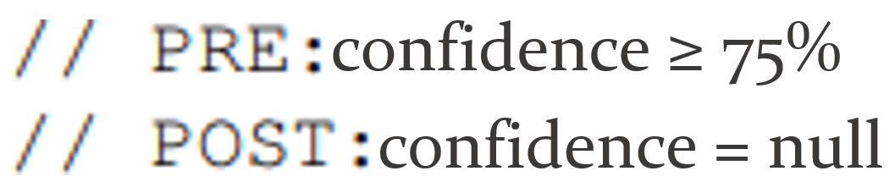

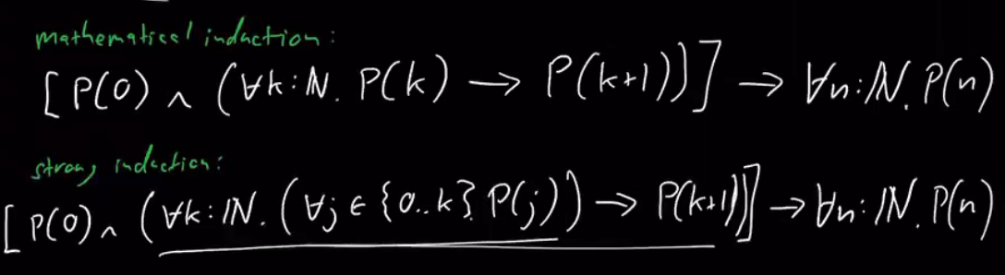

^ "It's unlikely they'll ask a question about these inductions" - Mark, Reasoning Revision Lecture, 1 week before the exam.

The exam:

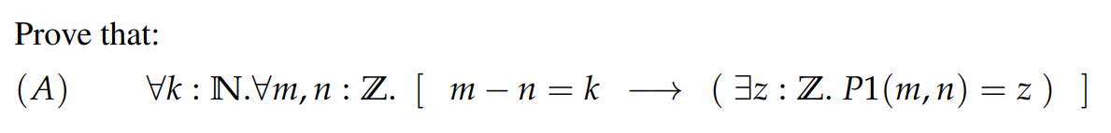



**Caktoos**

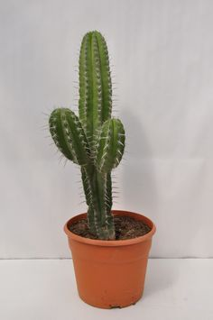

**Beeto**